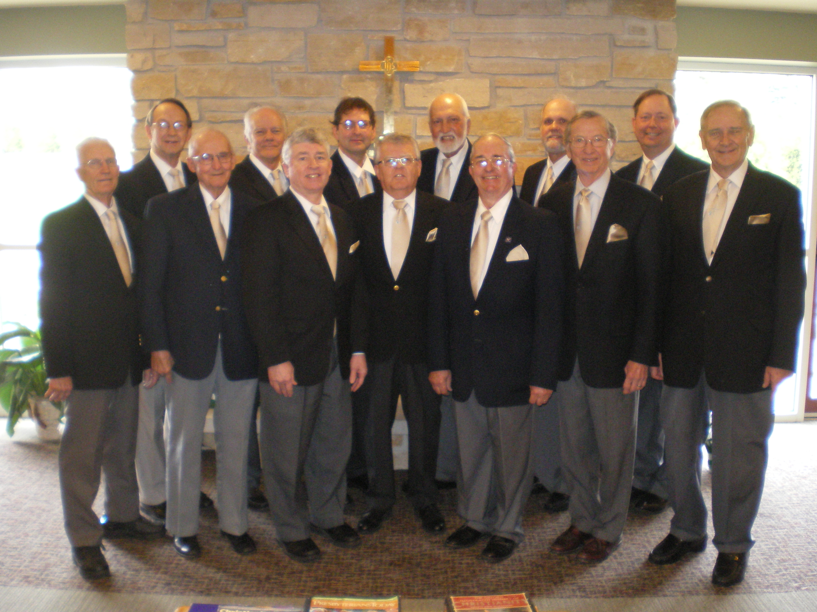
The Singing Men of Central Wisconsin In

Concert at:

First Presbyterian Church of Waunakee, Wisconsin
Sunday, October 9th at 4 PM

Free Will Offering

The Singing men have performed throughout Central Wisconsin at the Dean Foundation DocStar, Sauk Prairie Optimist Club Christmas event, Al Ringling Theatre Seniors fund raiser, Sauk County Historic Church Tour, and various area churches.

The Singing Men of Central Wisconsin is an independent, not-for profit Christian men’s choral group from Central Wisconsin with members from Madison, Reedsburg, Merrimac, Sauk City, Prairie du Sac and Waunakee.

